Week-6 (DAY-1) Hands-On
Problem: 1- SRP – Single Responsibility Principle
Scenario: Student Report Generator
A training institute like Codempower Academy maintains student information and generates performance reports. Currently, one class performs student data storage and report generation, which makes the code difficult to maintain.
Requirements:
1.Create a Student class with properties:
- StudentId
- StudentName
- Marks
2.Create a class responsible for managing student data.
3.Create a separate class responsible for generating reports.
4.The report should display:

Security Requirements (Secure Coding Practices)
Students must implement the following security measures:
Technical Constraints:
- Use C# (.NET Console Application).
- Each class must have only one responsibility.
- Do not mix data storage and report generation logic in the same class.
Expectations:
Students should implement at least three classes:
- Student
- StudentRepository
- ReportGenerator
Program Flow Diagram
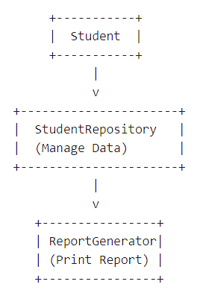
Learning Outcome:
Students will learn:
- Meaning of Single Responsibility Principle
- How to separate responsibilities
- How SRP improves maintainability and testing

Problem: 2- OCP – Open Closed Principle
Scenario: Discount Calculation System
An e-commerce system calculates discounts for different customer types:
- Regular Customer
- Premium Customer
- VIP Customer
The system should allow adding new discount types without modifying existing code.

Requirements:
- Create an abstract class or interface:
IDiscountStrategy
- Implement discount classes:
- RegularCustomerDiscount
- PremiumCustomerDiscount
- VipCustomerDiscount
- Each class should implement a method:
CalculateDiscount(double amount)
Technical Constraints:
- Use interface or abstract class
- Existing classes should not be modified when adding new discounts
- Follow Open for Extension, Closed for Modification
Expectations:
Students should implement:
- IDiscountStrategy
- 3 Discount Classes
- A class that calculates the final price

Program Flow Diagram:
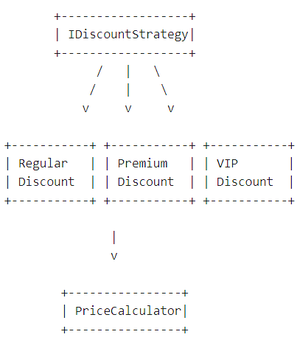
Learning Outcome:
Students will understand:
- Extending functionality without modifying existing code
- Use of interfaces and polymorphism
- Real-world use of Strategy Pattern

Problem 3- LSP – Liskov Substitution Principle
Scenario: Shape Area Calculator
A graphics application calculates the area of different shapes.
Any derived class should be able to replace the base class without breaking functionality.
Requirements:
- Create a base class or interface:
- Shape
- Derived classes:
- Rectangle
- Circle
- Each shape should implement:
- CalculateArea()
- A method should accept Shape object and calculate area.
Technical Constraints:
- Use method overriding
- Derived classes must not break base class behavior
Expectations:
Students should demonstrate that the program works correctly when:
- Rectangle object is used
- Circle object is used

Program Flow Diagram:
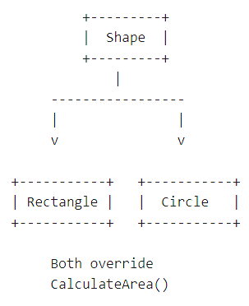

Learning Outcome:
Students will learn:
- Meaning of substitutability
- Importance of correct inheritance
- How polymorphism supports LSP

Problem 4- ISP – Interface Segregation Principle
Scenario: Office Printer System
An office has different machines:
- Basic Printer (Print only)
- Advanced Printer (Print + Scan + Fax)
If we create a single large interface, basic printers will be forced to implement unnecessary methods.
The task is to split the interface into smaller interfaces.
Requirements:
Create the following interfaces:
- IPrinter
- IScanner
- IFax
Classes:
- BasicPrinter → Print only
- AdvancedPrinter → Print + Scan + Fax
Technical Constraints:
- Follow Interface Segregation Principle
- Classes should not implement unnecessary methods
Expectations:
Students should implement:
Interfaces
- IPrinter
- IScanner
- IFax
Classes
- BasicPrinter
- AdvancedPrinter
Program Flow Diagram:
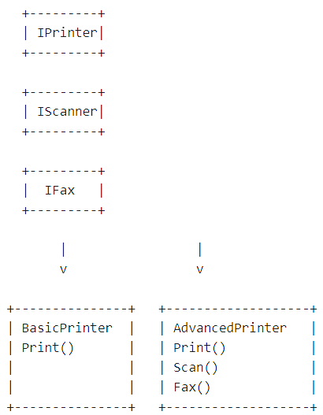

Learning Outcome:
Students will learn:
- Why large interfaces are bad
- How to design small focused interfaces
- Better maintainability and flexibility

Problem 5- Implementing Singleton Pattern
Scenario: Application Configuration Manager
A company is developing a console-based inventory management system.
The application needs to read application settings (e.g., database connection string, app name, version) from a configuration manager.
Since configuration settings should be loaded only once and shared across the entire application, multiple instances of the configuration manager must be prevented.
Therefore, the development team decides to implement the Singleton Design Pattern.
Program Flow Diagram:
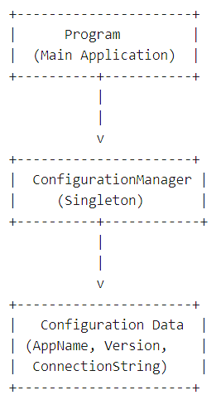
Requirements:
Students must implement:
- A class named ConfigurationManager
- Ensure only one instance of the class can be created.
- Provide a method:
GetInstance()
to retrieve the single object.
- Store configuration values such as:
- ApplicationName
- Version
- DatabaseConnectionString
- Demonstrate that multiple calls to GetInstance() return the same instance.
Technical Constraints:
- Use private constructor.
- Use static instance variable.
- Use thread-safe implementation (basic level optional).
- Console application using C# (.NET).
Expectations:
Students should:
- Prevent object creation using new.
- Access instance using:
ConfigurationManager.GetInstance()
- Print configuration details from multiple method calls.
Learning Outcome:
After completing this problem, learners will understand:
- Why Singleton is used
- How to restrict object creation
- Global shared objects
- Basic design pattern implementation in C#

Problem 6- Implementing Factory Pattern
Scenario: Notification Service
A company application sends notifications to users using different communication channels:
- Email
- SMS
- Push Notification
The application should not directly create objects using new.
Instead, a Factory class should determine which notification service to create.
Program Flow:

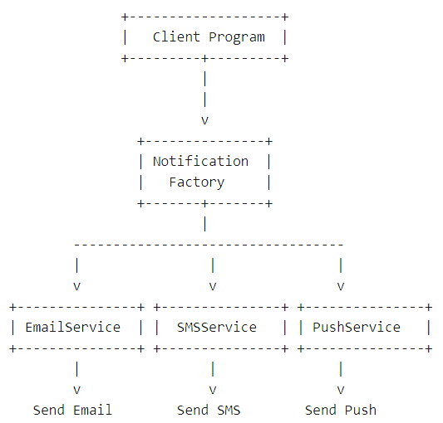

Requirements:
Students must implement:
- Interface
INotification
- Method:
Send(string message)
Classes
- EmailNotification
- SMSNotification
- PushNotification
Each class should implement INotification.
Factory Class
NotificationFactory
Method:
CreateNotification(string type)
Example:
CreateNotification("email")
CreateNotification("sms")
CreateNotification("push")
Technical Constraints
- Use interface-based design.
- Client should not instantiate concrete classes directly.
- Use Factory Pattern to create objects.
- Language: C# Console Application.

Expectations:
Students should demonstrate:
NotificationFactory factory = new NotificationFactory();
var notification = factory.CreateNotification("email");
notification.Send("Welcome to our service!");
Learning Outcome:
Students will learn:
- Decoupling object creation from usage
- Interface-based programming
- Open/Closed Principle basics
- Real-world object creation management

Problem 7- Implementing Repository Pattern
Scenario: Student Data Management System
A training institute needs a system to manage student information.
Instead of directly writing database access code in the main program, the development team decides to use the Repository Pattern.
The repository will act as a data access layer between the application and the data source.
For simplicity, student data will be stored in a List collection.
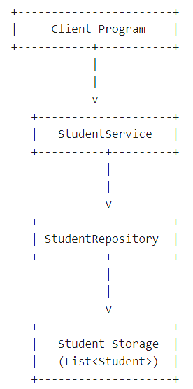
Requirements:
Create the following components:
Entity Class:
Student
Properties:
StudentId
StudentName
Course
Repository Interface:
IStudentRepository
Methods:
AddStudent(Student student)
GetAllStudents()
GetStudentById(int id)
DeleteStudent(int id)
Repository Implementation:
StudentRepository
Store data using:
List<Student>
Main Program
Demonstrate:
- Adding students
- Viewing students
- Finding student by ID
- Deleting student
Expectations:
Students should implement separation between:
Business Logic
↓
Repository Layer
↓
Data Storage

Learning Outcome:
Students will understand:
- Separation of concerns
- Data access abstraction
- Clean architecture basics
- How repositories simplify data operations

